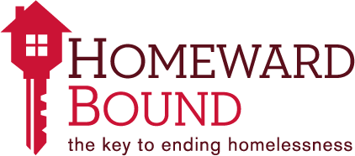

Volunteer Opportunity with Homeward Bound’s
Welcome Home Project
Homeward Bound ends homelessness by using a best practice model called Housing First. Housing First is a solution base approach to ending homelessness that centers on providing people experiencing homelessness with housing as quickly as possible and then providing services as needed to keep them is housing permanently. One of the services that Homeward Bound provides to everyone moving into housing is through our Welcome Home Program. Homeward Bound’s Welcome Home Program provides everyone moving into housing with basic furniture and households goods that are needed to help make their new housing a home. Homeward Bound has placed over 1,700 individuals and families into permanent housing since 2006 and we have an 89% retention rate which means that out of the 1,700 people that we have housed, 89% of them are still in housing.
The Welcome Home Program strives to supply each individual and family moving into housing with the basic furniture and household goods that are needed. The majority of people that we place in housing do not have much more than clothing so having the basic furniture and household goods needed to make housing feel like a home is a crucial part of our mission to keep people in housing permanently. Homeward Bound relies on donations and collections drives from our community to help us achieve this. By choosing to donate your time to Homeward Bound, you are a part of ending homelessness in our community and we could not do it without your support.
The Welcome Home Program always needs more furniture
- We are looking for volunteers with a truck to go and pick up furniture from our community and then take the furniture back to Homeward Bound’s new donation center.
- Homeward Bound will schedule everything so all you would have to do is show up with a friend. Get the schedule and go be an ambassador for Homeward Bound.
- We ask that volunteers commit to a three hour time period which will allow for 2 to 3 pick ups
Furniture and household goods are a crucial part in ending homelessness!
If you are interested or would like more information, please contact Ashley Campbell at ashley@homewardboundwnc.org or call (828)777-1886

